16.3 Alkenes
Name: ____________________ Class: ____________________ Due date: 3.8
$C_{n}H_{2n+2}$1. Which compound is not an alkane, ? （ ）
${CH}_{3}{CH}_{2}{CH}_{2}{CH}_{3}$$({CH}_{3})_{2}{CHCH}_{3}$${CH}_{3}{CHCHCH}_{3}$$({CH}_{3})_{2}CH$A. B. C. D. 2

$C_{n}H_{2n}$2. Alkenes have the general formula
Which of the following is an alkene? （ ）
A CH₂ B C₂H₂ C C₃H₆ D C₄H₆

3. The diagram represents ethene.
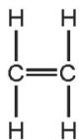
Which compound has chemical properties similar to those of ethene? （ ）
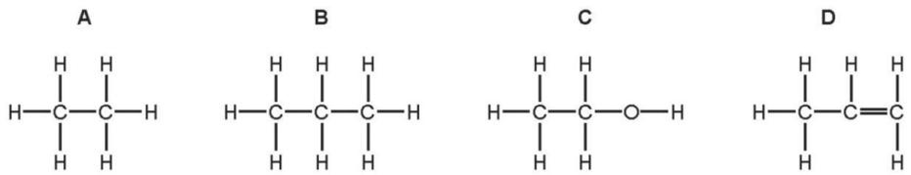
4. Increasing the number of atoms in one molecule of a hydrocarbon increases the amount of energy released when it burns.
What is the correct order? （ ）
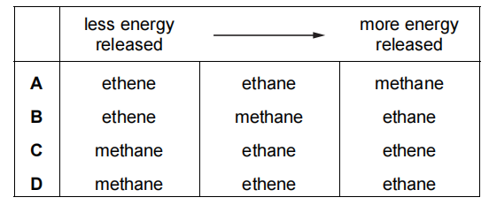
5. Alkenes are manufactured by cracking hydrocarbons obtained from petroleum.
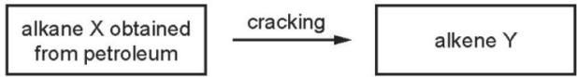
Which row describes the process of cracking? （ ）
 | size of X molecules | size of Y molecules | catalyst required | temperature required
A | large | small | no | low
B | large | small | yes | high
C | small | large | no | low
D | small | large | yes | high

6. Butene is an alkene which is manufactured by cracking hydrocarbons.
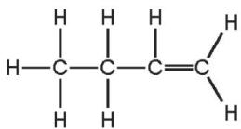
Which hydrocarbon can be cracked to make butene? （ ）
$C_{2}H_{6}$$C_{10}H_{22}$${CH}_{4}$$C_{3}H_{8}$A ethane, B decane, C methane, D propane,
7. Which products are obtained by the cracking of an alkane? （ ）
 | alkene | hydrogen | water
A | ✓ | ✓ | ✓
B | ✓ | ✓ | ✗
C | ✓ | ✗ | ✓
D | ✗ | ✓ | ✓

8. When a long chain hydrocarbon is cracked, the following products are produced.
$C_{3}H_{8}$$C_{2}H_{4}$$C_{3}H_{6}$$C_{2}H_{6}$1 2 3 4
Which products would decolourise bromine water? （ ）
A 1 and 4 B 2 and 3 C 2 only D 3 only

9. Which columns describe the hydrocarbons ethane and ethene? （ ）
 | 1 | 2 | 3 | 4
state at room temperature | gas | gas | liquid | liquid
reaction with oxygen | burns | burns | burns | burns
reaction with aqueous bromine | no reaction | decolourises bromine | no reaction | decolourises bromine
A 1 (ethane) and 2 (ethene)
B 1 (ethane) and 4 (ethene)
C 2 (ethene) and 3 (ethane)
D 3 (ethane) and 4 (ethene)

10. Chlorine reacts with methane.
Which statements are correct? （ ）
1 The reaction takes place in the dark.
2 The reaction of chlorine with methane forms chloromethane.
3 Chloromethane reacts with chlorine to produce dichloromethane.
4 The reaction of chlorine with methane is an addition reaction.
A 1 and 2 B 1 and 3 C 2 and 3 D 3 and 4

11. During the process of cracking hydrocarbons, an ……. 1 ……. is converted into an ……. 2 …….
The presence of an ……. 3 ……. can be shown by a visible reaction with ……. 4 …….
Which words complete gaps 1, 2, 3 and 4? （ ）
 | 1 | 2 | 3 | 4
A | alkane | alkene | alkene | bromine
B | alkane | alkene | alkene | steam
C | alkene | alkane | alkane | bromine
D | alkene | alkane | alkane | steam

12. The structures of four organic compounds are shown.
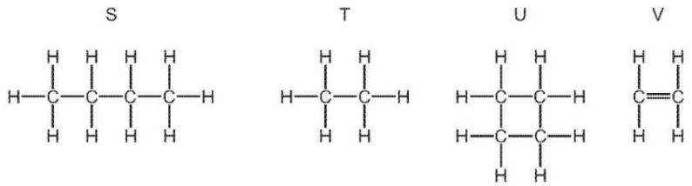
Which compounds are unsaturated? （ ）
A S only B T and U C U only D V only

13. A chemist carried out a cracking reaction on a hydrocarbon, X, and obtained two products, Y and Z.
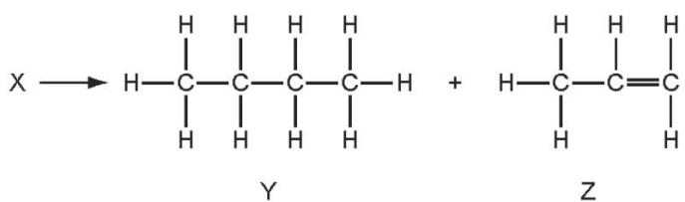
The chemist then wrote the following statements in his notebook.
1 A molecule of X has 7 carbon atoms.
2 Y is unsaturated.
3 Z will decolourise bromine water.
Which statements are correct? （ ）
A 3 only B 1 and 2 C 1 and 3 D 1,2 and 3

$C_{20}H_{42}$14. Alkenes and simpler alkanes are made from long-chain alkanes by cracking. a.Complete the following equation for the cracking of the alkane .
$$C_{20}H_{42}→2C_{4}H_{8}+2C_{2}H_{4}+…………$$
b.Alkenes such as butene and ethene are more reactive than alkanes.
Alkenes are used in the petrochemical industry to make a range of products, which includes polymers and alcohols.
c.Dibromoethane is used as a pesticide.
Complete the equation for its preparation from ethene.
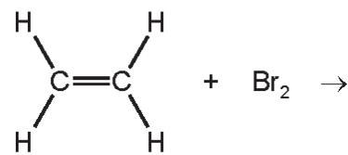 [1]
15. Alkanes and alkenes are both series of hydrocarbons.
What is the difference between these two series of hydrocarbons?
.......................................................................................................................................
...................................................................................................................................[2]

16. The table shows the structures of four hydrocarbons.
P | Q | R | S
CH3-CH₃ | CH₂=CH₃ | CH₂=CH-CH₃ | CH₂=CH-CH2-CH₃
Compound P is saturated.
What is meant by the term saturated?
c.Compound P undergoes a substitution reaction with chlorine.
i.What is meant by the term substitution reaction?
ii.State a condition required for this reaction to occur.
Write a chemical equation for this reaction.
d.Compound R undergoes an addition reaction with bromine.
i.Why is this reaction an addition reaction?
ii.A compound containing bromine is formed in this reaction.
Draw the structure of this compound. Show all of the atoms and all of the bonds.
Show all of the atoms and all of the bonds.
Name this unbranched isomer of compound S.
structure

name..........................................................................................................................[2]

17. Cracking is used to convert long chain alkanes into shorter chain alkanes and alkenes.
Alkenes are unsaturated compounds.
$C_{10}H_{22}$Decane, can be cracked to give propene and one other product.
Complete the chemical equation.
$C_{10}H_{22}→C_{3}H_{6}+$ 。

i.What is meant by the term unsaturated?
......................................................................................................................................
........................................................................................................................................ii.Describe a test to show that propene is an unsaturated compound.
test..............................................................................................................................
.......................................................................................................................................
result.........................................................................................................................[2]

18.(周测内容) Please write down down the names of the following organic compounds
i. C₂H₄ ii. C₃H₆

